Jake Shoemake

4/2/24

CMIS 320

Project 2

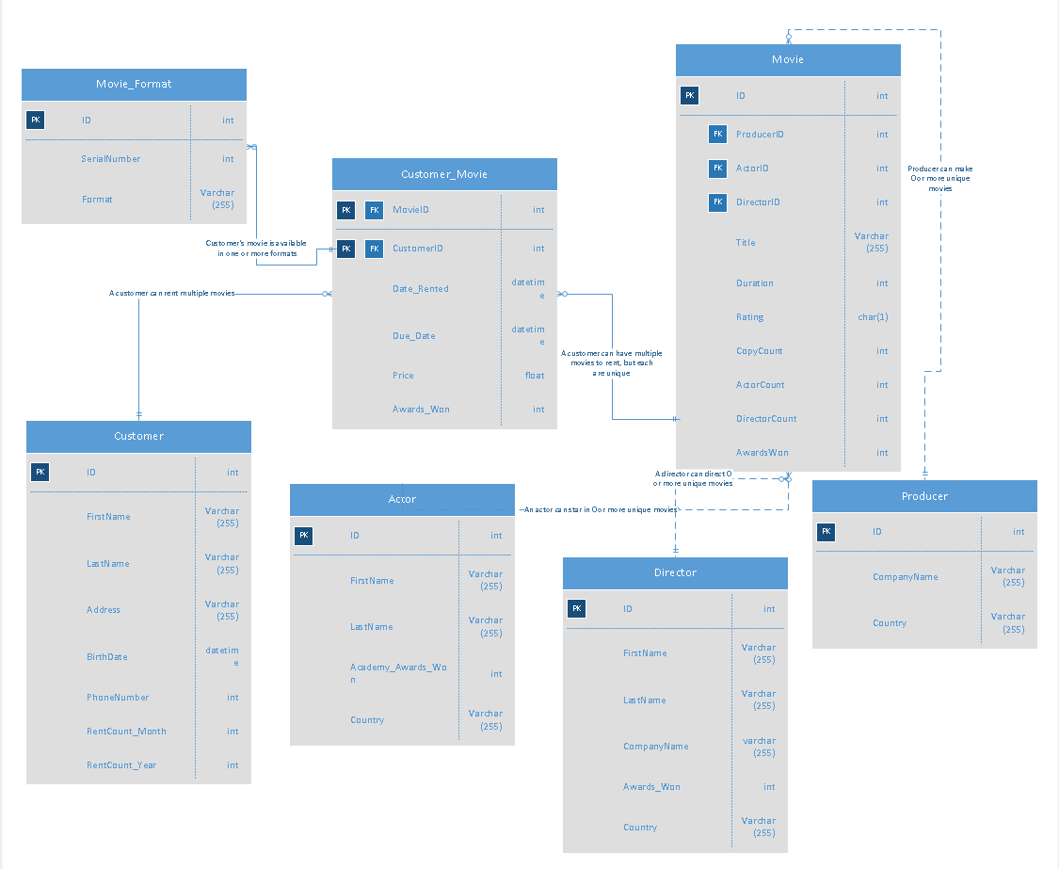

| **Mom & Pop Database** | | | | |
| --- | --- | --- | --- | --- |
| **Entity Name** | **Attributes** | **PK/FK?** | **Data Type** | **Description** |
| **Producer** | ***ID*** | PK | int | Primary Key for Producer entity |
|  | CompanyName | no | varchar(255) | Producer company name |
|  | Country | no | varchar(255) | Producer’s country |
| **Movie** | ***ID*** | PK | int | Primary Key for Movie |
|  | *ProducerID* | FK | int | Foreign Key that points to Producer |
|  | *ActorID* | FK | int | Foreign key pointing to Actor |
|  | *DirectorID* | FK | int | Foreign key pointing to Director |
|  | Title | no | varchar(255) | Movie Title |
|  | Duration | no | int | Length of the Movie |
|  |  |  |  |  |
|  | Rating | no | char(1) | Customer rating of the Movie |
|  | CopyCount | no | int | Number of copies that are currently available |
|  | ActorCount | no | int | Number of actors/actresses in the movie |
|  | DirectorCount | no | int | Number of directors in the movie |
|  | AwardsWon | no | int | Number of awards the movie won from actors, directors, or producers |
| **Customer_Movie** | ***MovieID*** | PK/FK | int | Primary key for Customer_Movie and foreign key pointing to Movie entity |
|  | ***CustomerID*** | PK/FK | int | Primary key for Customer_Movie and foreign key pointing to Customer entity |
|  | Date_Rented | no | datetime | Date in which the movie was rented |
|  | Due_Date | no | datetime | Due date of the rented movie |
|  | Price | no | float | Pricing of the rental movie |
|  | Awards_Won | no | int | Number of Academy Awards the movie has won by the movie itself, actors, or directors |
| **Director** | ***ID*** | PK | int | Primary Key for the Director entity |
|  | FirstName | no | varchar(255) | Director’s first name |
|  | LastName | no | varchar(255) | Director’s last name |
|  | CompanyName | no | varchar(255) | Director’s company of occupation |
|  | Awards_Won | no | int | Number of academy awards the director has won |
|  | Country | no | varchar(255) | Director’s country |
| **Customer** | ***ID*** | PK | int | Primary Key for Customer entity |
|  | FirstName | no | varchar(255) | Customer’s first name |
|  | LastName | no | varchar(255) | Customer’s last name |
|  | Address | no | varchar(255) | Customer’s address |
|  | BirthDate | no | datetime | Customer’s birth date |
|  | PhoneNumber | no | int | Customer’s phone number |
|  | RentCount_Month | no | int | Number of movies the customer has rented last month |
|  | RentCount_Year | no | int | Number of movies the customer has rented throughout the year |
| **Actor** | ***ID*** | PK | int | Primary Key for Actor entity |
|  | FirstName | no | varchar(255) | Actor’s first name |
|  | LastName | no | varchar(255) | Actor’s last name |
|  | Academy_Awards_Won | no | int | Number of Academy Awards the actor has won |
|  | Country | no | varchar(255) | Actor’s Country |
| **Movie_Format** | ***ID*** | PK | int | Primary key for Movie_Format entity |
|  | SerialNumber | no | int | The serial number unique to the customer_movie entity |
|  | Format | no | varchar(255) | Format of the customer’s movie |